Hydrosphere (freshwater)
Study Guide
Concept 1: The water cycle recycles the Earth’s supply of water through process like precipitation(gain) and evaporation(loss).
Concept 2: Groundwater is a source of fresh drinking water stored in layers of a soil profile.
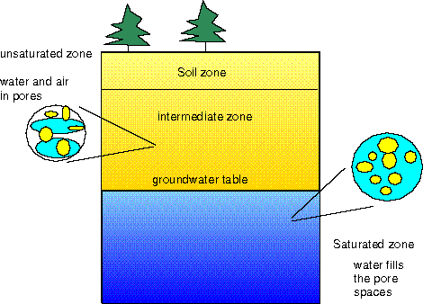
- Water is stored in an aquifer (zone of saturation)
- Water is filtered through permeable layers of soil above the aquifer (zone of aeration)
- Higher porosity = greater permeability (ex: loose rocks vs. clay)

Concept 3: Intersections between groundwater and the Earth’s surface contribute to water on the surface in features like springs, geysers, streams, lakes, etc. Manmade features built to access groundwater are called wells.
Concept 4: How water moves on the surface is determined by the landscape and properties of the surface water.
- Regions that collect precipitation are watersheds, watersheds are separated by divides
- The purpose of streams is to carry water and sediments to a larger body of water
Properties of streams
Gradient- how steep a stream bed is (steeper = higher velocity)
Velocity – speed of water (higher velocity = more erosion)
Discharge – volume of water (greater discharge = more sediments)
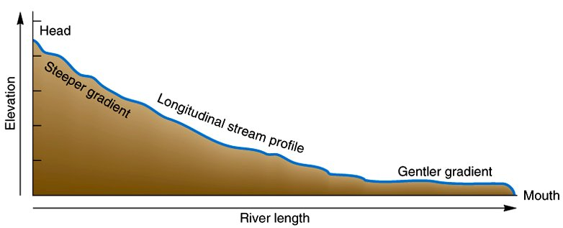
Concept 5: Stream erosion is responsible for transporting sediments (of different sizes), shaping the stream channel (lengthening the stream or widening the channel), and depositing sediments

Stream features
Meanders Tributaries
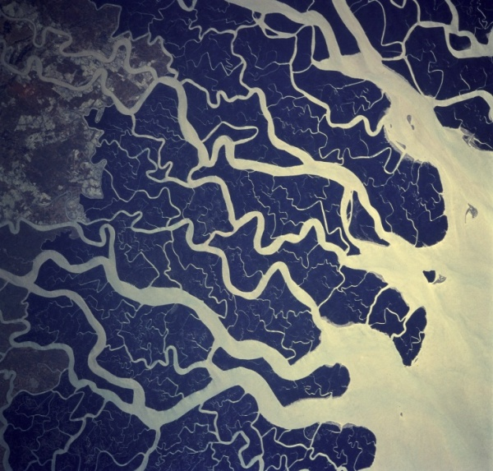
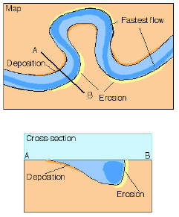

Concept 6: Stream deposition drops off sediments in areas where the stream velocity is lower. Sediments are often sorted according to size because of the energy needed to carry them (large sediments need faster currents, small sediments can be carried in slower currents)

Deposition Features

Estuaries: freshwater mixed with salt water

Wetlands: covered in water most of the year (ex: marsh, swamp)

Delta Levee
Sorted large sediments small sediments Can be natural or manmade (come from flooding)
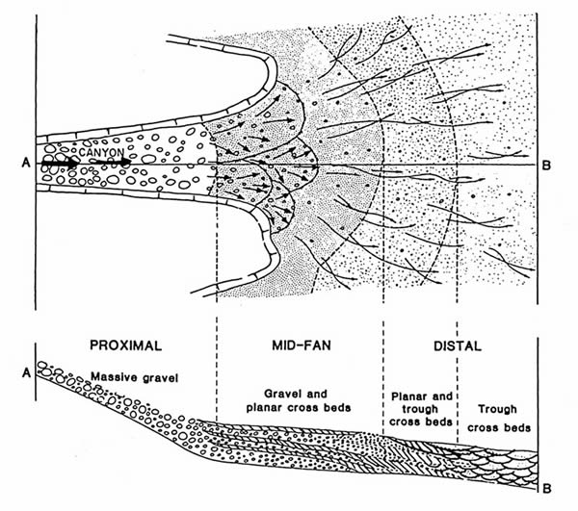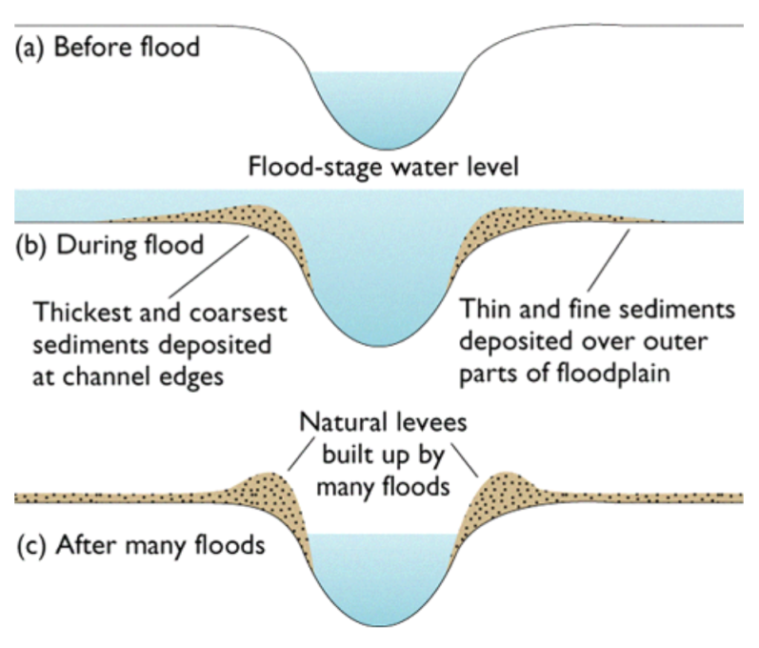

Concept 7: Flooding is a natural occurrence that means an overflow of water in the stream channel onto land (floodplains). Flood control methods include levees, dams, and limiting development.

